Statistics and Probability Assignment

1. Karina makes mistakes in class according to Poisson process with an average rate of 1.2 mistakes per class.

● What is the probability that Karina makes at least 3 mistakes during one class?

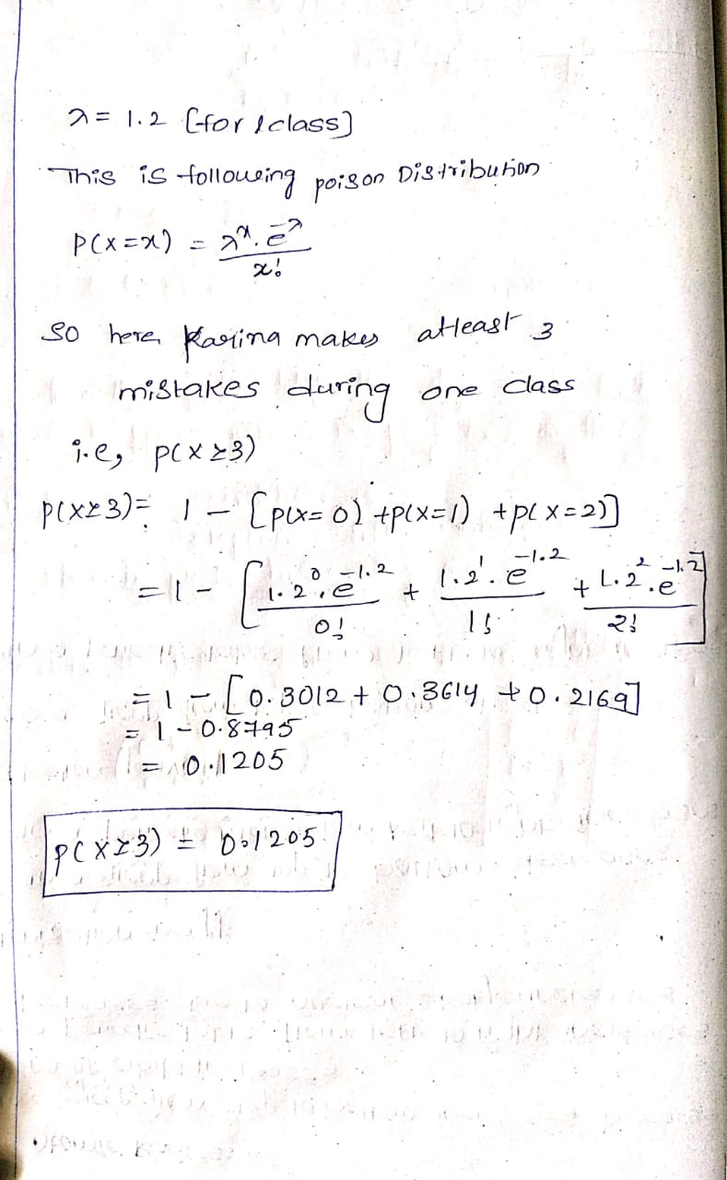

● What is the probability that Karina makes exactly 10 mistakes during two weeks of classes?



2. When Stephan plays chess against his favourite computer program, he wins with probability 0.60, loses with probability 0.10, and 30% of the games result is a draw. Assume that the event is independent.

● Find the probability that he wins 7 games and draws 5 games.

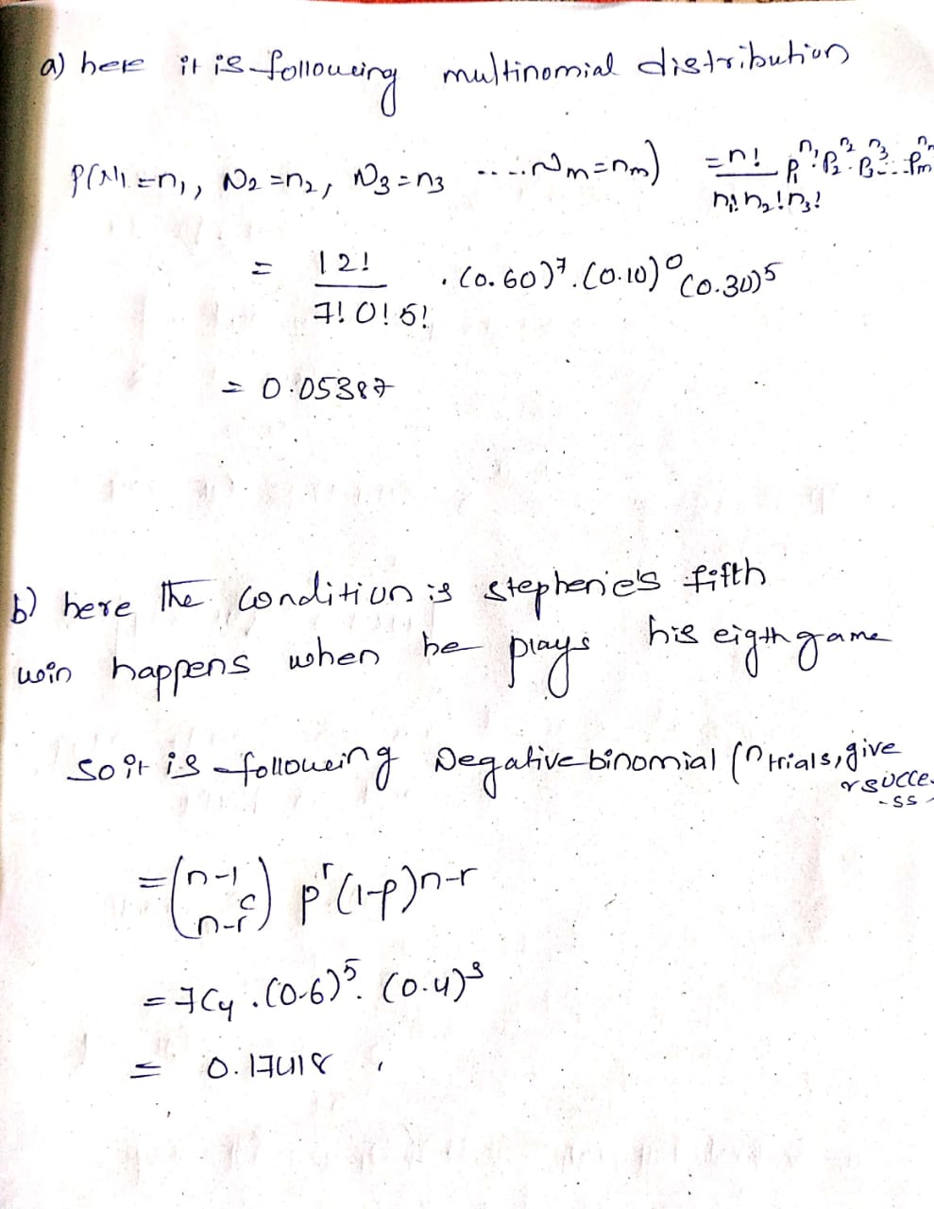

● Find the probability that Stephane’s fifth win happens when he plays his eighth



3. The personnel manager of a firm wants to compare the job satisfaction level of the employees among the firm’s Finance, Purchase and Sales departments. A battery of questions are administered to randomly selected employees from each of the three departments resulting in the following job satisfaction level scores:

Finance: 14, 12, 13, 12, 11 Purchase: 18, 19, 20, 18, 16 Sales: 10, 12, 17, 11, 13

|  |  |  |  |  |  |
| --- | --- | --- | --- | --- | --- |
| Finance | 14 | 12 | 13 | 12 | 11 |
| Purchase | 18 | 19 | 20 | 18 | 16 |
| Sales | 10 | 12 | 17 | 11 | 13 |

Answer the following:

a. Is there a significant difference in job satisfaction level among the employes

From the three different departments?

b. Detect the departments which differ in job satisfaction level of its employees.

c. What assumptions are needed for validating the above analysis?

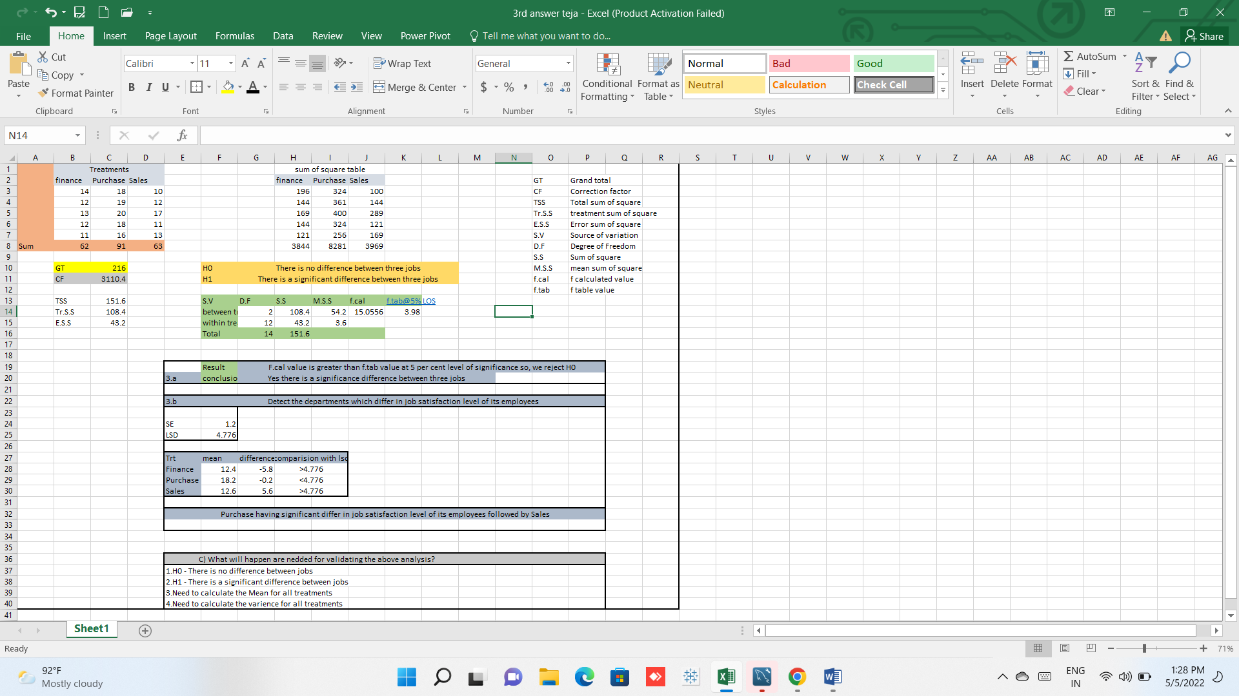

4. A normal distribution has standard deviation 16. We have null hypothesis (h 0): mean = 5 and alternative hypothesis (h 1): mean = k.

We reject the null hypothesis when > k-2

Find k and sample size (n) when P (Type 1 error) = 0.228 and P (Type 2 error) = 0.1587

5. A computer manufacturing company has three plants at X, Y and Z. To measure how many employees at these plants know about total quality management, a random sample of six employees was selected and a quality awareness test was administered. The test scores are given below:

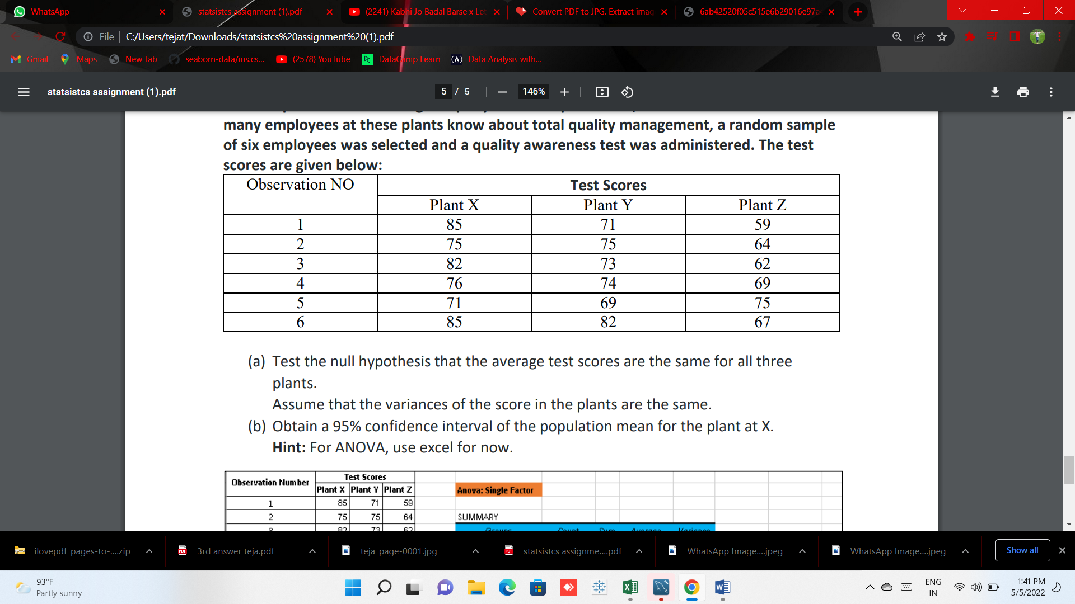

(a) Test the null hypothesis that the average test scores are the same for all three plants.

Assume that the variances of the score in the plants are the same

(b) Obtain a 95% confidence interval of the population mean for the plant at X. Hint: For ANOVA, use excel for now.

Answer:-

